


Final Report

Title： Mathematical model construction and visual analysis of the infectious disease model

Number 20202505018
Name 邸亦龙 (Hermann)
College international college
Major software engineering
Class Class two

2023年 6 月 3 日

Mathematical model construction and visual analysis of the infectious disease model

Abstract

While finally liberalizing the policy, it seems that the epidemic is getting far away from us. But we know that the disease outbreak with the flow of people and contact with each other in regional rapid spread and spread, the epidemic will not disappear, more not in the short term, therefore, by proposing a regional population flow and the flow of epidemic transmission model (SEIR model) is very necessary. I believe that this model needs to consider the flow of the population, the number of susceptible and latent population, so as to predict the change of the confirmed population.In the following article, I'll take the COVID-19 virus outbreak in the world as an example to build a mathematical model and present it in a visual operation.

Key words: COVID-19; SEIR model; epidemic prevention and control;

Catalogue

1 Introduction………………………………………………4
2 Methodology…………………………………………………5
2.1 Information on the spread of COVID-19………………………5
2.2 Model applicable to analyze the spread of COVID-19………7
2.3 How to be selected in multiple models………………………8
2.4 Necessary assumptions…………………………………………9
2.5 Modeling ideas and building…………………………………10
2.6 Establishment of the SEIR prediction model………………10
2.7 Parameter fit…………………………………………………12
2.8 Results calculation……………………………………………12
3 Results and visualization………………………………………13
Reference…………………………………………………………16
Appendix……………………………………………………………17

1 Introduction
According to my inquiry of multiple data, I now summarize the approximate time line of the spread of COVID-19.
In December 2019,27 cases of viral pneumonia were found in Wuhan, Hubei Province, most of which were seafood city businesses, all of which were diagnosed as viral pneumonia or lung infection. On December 31,2019, the expert team of the National Health and Family Planning Commission arrived in Wuhan to test the relevant virus typing. On January 7,2020, the expert said it was novel coronavirus, and preliminary progress was made in identifying the etiology of viral pneumonia of unknown cause in Wuhan. Human-to-human transmission of the new pneumonia. The National Health Commission has included novel coronavirus pneumonia into the management of class B of notifiable infectious diseases, and adopted prevention and control measures for Class A infectious diseases. The nucleic acid test of the pathogen was completed on January 10, and the Wuhan Municipal Health Commission announced the detected cases of viral pneumonia of unknown cause. On January 12,2020, the World Health Organization officially named the novel coronavirus that caused the Wuhan pneumonia epidemic as novel Coronavirus 2019, and at the same time, the novel coronavirus began to spread globally.
By February 2023, there have been different outbreaks of COVID-19 in China, and finally gradually realized the "liberalization". However, in any case, we want to thank the medical workers who have carried the health of the people in recent years, and at the same time, adhere to the national policy in the context of liberalization.

2 Methodology
2.1 Applied to models that analyze the spread of COVID-19
In order to study the most suitable for analyzing the new crown outbreak mathematical model, I from several common mathematical model as a reference, because our country in the beginning of the 21st century had encountered SARS outbreak, so the infectious disease prevention and control model is not completely blank, I compiled the following models from the network, and make a brief introduction.
1, SI model
In the classical infectious disease model, the states of the N individuals within the population (Population) can be divided into the following categories:
Suscnerability state (Susceptible): An individual is susceptible before infection, that is, the individual may be infected by the neighboring individual.
Infection status (Infected): An individual infected with a virus is called in an infection state., That is, the individual also infects its neighbors with a certain probability.
Removal state (Remove, Refractory or Recovered): also becomes an immune state or recovery state, when an individual has experienced a full infection cycle, the individual is no longer infected and therefore can not be considered.
The SI transmission model is the simplest disease transmission model, in which all individuals are only likely to be in one of the two states: the susceptibility (S) state or the infection (I) state.
Individuals in the SI model are permanently infected once once infected.
At a given time t, the groups S (t) and I (t) represent the number of individuals that are susceptible and infected at that time, respectively
S (t) + I (t) is always equal to N, and here, N is the total number of individuals. Increasing at time t, the contact of susceptible individuals with infected individuals leads to an increase in the number of infected individuals. The probability of adding the disease transmission due to contact between individuals is β, and the disease will transmit the disease to susceptible individuals with probability β only when contacted between infected individuals and susceptible individuals. At time t, the proportion of susceptible individuals is S (t) / N, the number of infected individuals is I (t), and the number of susceptible individuals will decrease at a rate of change as follows
ds/dt = -β*S(t)I(t)/N
At the same time, the number of infected individuals increases with the opposite rate of change to susceptible individuals,
ds/dt = βS(t)*I(t)/N
The proportion of individuals being susceptible and infected at time t is noted as, respectively,
s(t)=S(t)/N
i(t)=I(t)/N
Apparently,
s (t) + i (t) is equal to 1, and the previous formula can be written
ds/dt=-βsi
di/dt=βsi
D. e. di / dt = β i (1-i)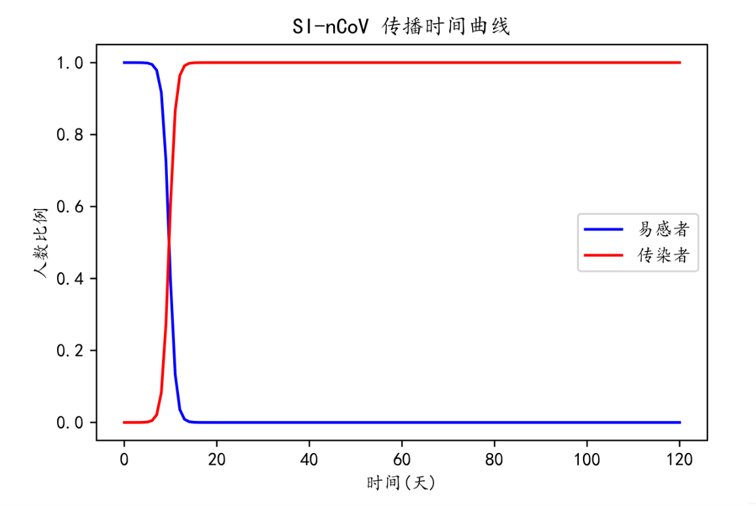
2, SIS model
Adding the probability of rehabilitation to the SI model, namely the cure rate
S: susceptible person
I: infected person
a: infection rate
b: cure rate
condition:
1, the total number of people during disease transmission N is unchanged, N=S + I
2. The number of daily contacts of each patient is a fixed value
3, the daily cure rate of patients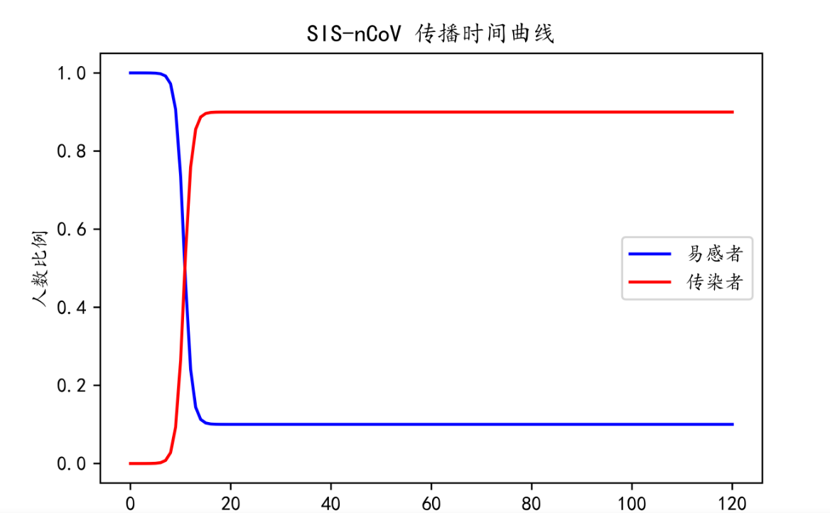
SEIR model
Continue to introduce latkers based on the SI model
S: susceptible a: contact rate
E: latent agent b: Infection rate
I: infected person i: turnover rate
R: recovered patient r: cure rate
D: Death person k: case fatality rate
The differential equation is: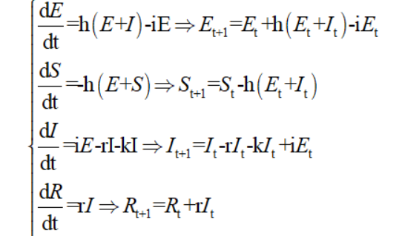
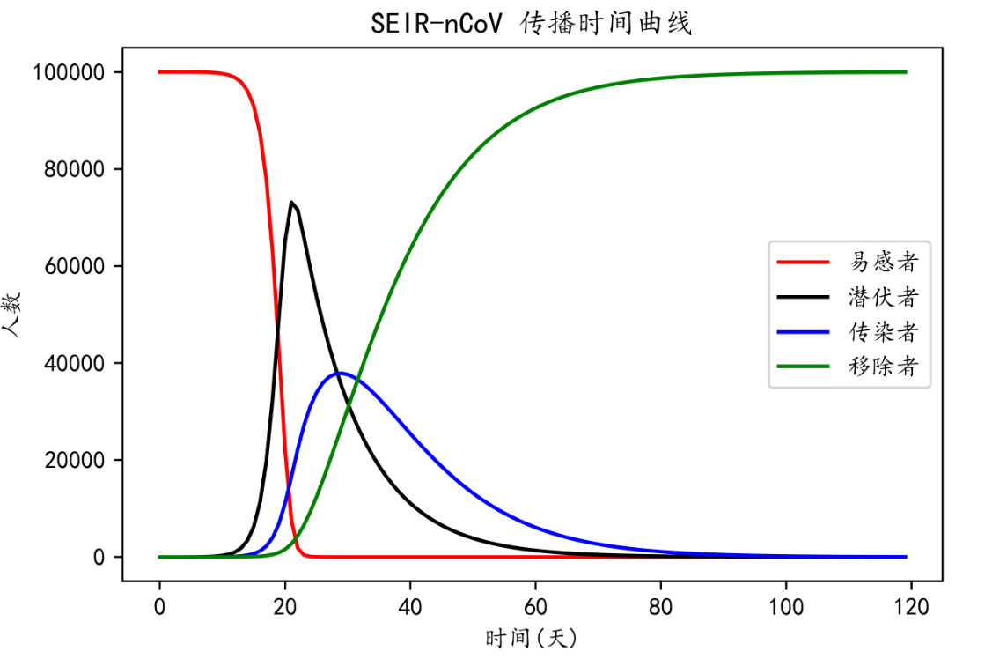

2.2 How to be selected in multiple models
In the second chapter, I introduced the three models I want to choose, but in order to more accurately and reasonably analyze the characteristics of the epidemic transmission, we should combine the characteristics of the three models and analyze them, so as to choose one model for establishment and analysis. After consulting the relevant literature, it was found that the common infectious disease models are divided into SIS, SIR, SIRS, SEIR models, etc., according to the types of infectious diseases, which are used to study the transmission speed, spatial range, transmission route and other problems of infectious diseases, and to guide the prevention and control of infectious diseases. S, E, I, R, r, β, γ, α parameters involved in the model: the S class: indicating susceptible (Susceptible), Who has not become ill, But the lack of immune competence, vulnerable to infection after contact with infected people; Class E: indicates the exposed (Exposed), In contact with an infected person, But those who are not able to infect others, Applicable to infectious diseases with a long incubation period; Class I: represents the affected person (Infectious), A person who has an infectious disease, Can be transmitted to class S members, Make it a Class E or Class I member; Class R: represents the recovered person (Recovered), A person who is isolated or immune due to an illness. If the immune period is limited, class R members can be returned to class S. R: number of susceptible infected patients (I) per day; β: infection coefficient, determined by the transmission ability of the disease itself and the prevention and control ability of the population; γ: recovery coefficient is generally the reciprocal of the course of disease, such as the course of influenza for 5 days, then its γ is 1 / 5; α: the probability of latent disease, generally the reciprocal of the incubation period. So why do we choose the SEIR model as the base model? There are two reasons for combining online views and analysis.
(1) Reason 1: Compared with several other infectious disease models, the SEIR model has several more contents. Based on the analysis of the epidemic, we can know that the "COVID-19" epidemic is an incubation period of 14 days, and when the infected person becomes cured or autoimmune, antibodies are produced in the body and will not become susceptible to be infected. So the E term must exist in the model. The SEIR model fits with the infectious characteristics of COVID-19.
(2) Reason 2: At the same time, some existing data show that many professional research teams are using this model to study the development of the epidemic situation. For example, Academician Zhong Nanshan's team published the title of "Modified SEIR and AI prediction of the epidemics trend ofCOVID-19 in China under public health" in the Journal of Thoracic Disease Journal of Chest Diseases interventions " (Based on the SEIR optimization model and the AI forecast of COVID-19 development trends in China under public health intervention).[1]
2.3 Data collection after determining the model
In view of the fact that China is in the open stage, the data obtained have not been carefully deliberated, and there are many we media on the Internet, so it is difficult to distinguish the true and false data, so I decided to search the data published by the previous authoritative articles as the data source of this research. Through searching the Internet, I found data on the COVID-19 pandemic (cure rate, mortality rate). The following content is quoted from the Beijing News website, "What do the five top papers say about the spread of novel coronavirus"?》
(1) Novel coronavirus has low pathogenic and moderate transmissibility
The novel coronavirus is the third new coronavirus in the past 20 years to infect people across species. The previous two were SARS coronavirus in 2003 and Middle East Respiratory syndrome coronavirus (MERS) in 2014.
According to a paper, "Pathogenicity and Transmissibility of 2019-nCoV- -A Quick Overview and", published in the journal Microbes and Infection (Microorganisms and Infection)
By Comparison with Other Emerging Viruses (2019-Rapid Overview of Pathogenesis and Transmissibility —— of nCoV and Comparison with other emerging viruses), we can know that novel coronavirus is not as strong as SARS virus in terms of virus rate or R0.
However, it was more infectious than influenza A in 2009 and greater R0) in 2014. This is reflected in the number of infections, namely the greater number of confirmed cases of COVID-19. But overall, the current novel coronavirus appears to be only relatively low pathogenic and moderate transmissibility.
(2) The epidemic situation in other cities has a lag rate of 1-2 weeks compared with Wuhan
According to another paper, Nowcasting and forecasting the potential domestic and international spread of the 2019-nCoV outbreak originating in Wuhan, published in the Lancet, on January 31, China: a modelling study (Prediction and prediction of potential domestic and international Transmission of the 2019-nCoV Outbreak originating in Wuhan, China: A Model Study), The epidemic situation in several major cities in China has grown exponentially, But it is probably about 1-2 weeks behind the outbreak in Wuhan.
These are some of my data from two articles. In the modeling process, I will also search for other data and add them to the model, so as to get more rigorous results.
2.4 Necessary assumptions
In order to simplify the model without losing its essential role, we now make some provisions on the data.
(1) Suppose that the total population is a constant;
(2) The cured individuals will not be reinfected;
(3) The population is divided into susceptible population, latent population, infected population and rehabilitation population;
(4) The number of cured and deaths in the recovered population;
(5) Regardless of the role of the vaccine;
(6) Each individual has equal contact opportunities.
2.5 Modeling ideas and building
By query online information, I think you can from the traditional disease transmission model (SIS, SIR, SEIR, etc.), choose a model, adjust, establish model of infectious diseases, combined with the spread of the coronavirus characteristics, using the existing sample estimate a general parameters, and establish the appropriate mathematical model of infectious diseases, so as to more accurately estimate the development trend of outbreak, of course, this is a more complex and professional problem. I am not a student majoring in this field, but this problem does not affect me from using the knowledge of mathematical modeling to solve it.
I decided not to use the recent data simulation outbreak development form, on the one hand, the reason is that I am not good estimates of the parameters, the parameters are considered, on the other hand, data does not support the model derivation, especially the outbreak of the government intervention factors, social public opinion, the epidemic development trend will produce certain influence, should take related factors into consideration, so this problem is relatively complex process, so I decided to adopt the previous data. Finally, the cities involved are mainly those in the early stages of the epidemic, such as Hubei, Wuhan, Zhejiang and Guangdong.
2.6 Establishment of the SEIR prediction model
Assuming the population overall N, four populations are defined as shown in the table below.
At the beginning of the virus S=N, then S changes to E at α per day, E to I at σ per day, and I to R at β per day:
The classical differential equation corresponding to the SEIR model is: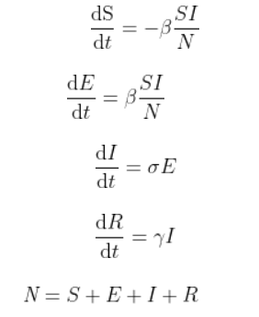
Functions S (t), E (t), I (t), R (t) involved in the model
S (t) means the number of healthy individuals on day t, E (t) is the number of individuals exposed to infected persons on day t, I (t) is the number of infected individuals on day t, R (t) is the number of individuals immunized individuals on day t, N (t) is the number of the entire population, fixed to N under assumptions.[2]
The model for the classic infectious disease model, due to the epidemic infection factors than common infectious diseases is more complex, and has the incubation period, so introduce three additional parameters, a.,, a, respectively incubation period self-healing into rehabilitation, namely contact with infected but not infected, sick after cured to the probability of recovery, latent infection rate of susceptible people.The changed equation：
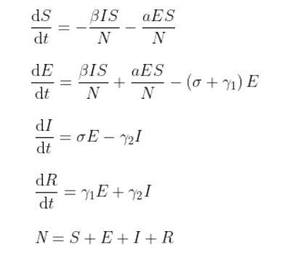

2.7 Parameter fitting
From the basic understanding of the mathematical model, we know that to solve the model, we need parameters.
Next, the parameters will be determined to complete the mathematical modeling.
N: Total population: crawl the population data of each province.
R: Number of contacts: Through Baidu Encyclopedia, no one contacts about 20 people every day on average
B: transmission probability; and y: the cure rate is more special.
Method of transmission probability and cure rate and d rate:
Why say these three values is special, in modeling at first I like directly use national statistics outbreak spread probability and cure rate, but think carefully about this is not correct, because first we simulate the epidemic trend of no intervention, so the transmission rate and cure rate are different from the reality (we used the city to prevent the source of infection, with masks and gloves to limit the way of transmission is, finally also use the vaccine way to increase the cure rate and d rate), so directly use online statistics is not correct.
I refer to the model studied by Academician Zhong Nanshan's team for data analysis:
Suppose, the first case and the virus are mutated by itself, so the number of infections in the initial test is 1, and S=N-1 S is about equal to N
So dI / dt = rbIS / N-yI is roughly equal to rbI-yI = I (rb-y) we manually solve the differential equation I = exp ((rb-y) * t)
We can calculate the transmission probability, the cure rate and the d rate of the novel coronavirus (COVID-19) without intervention by using the early Hubei data fitting function.
2.8 Results calculation
After the parameter fitting is completed, we need to use the various data queried on the Internet, the first is the population migration data.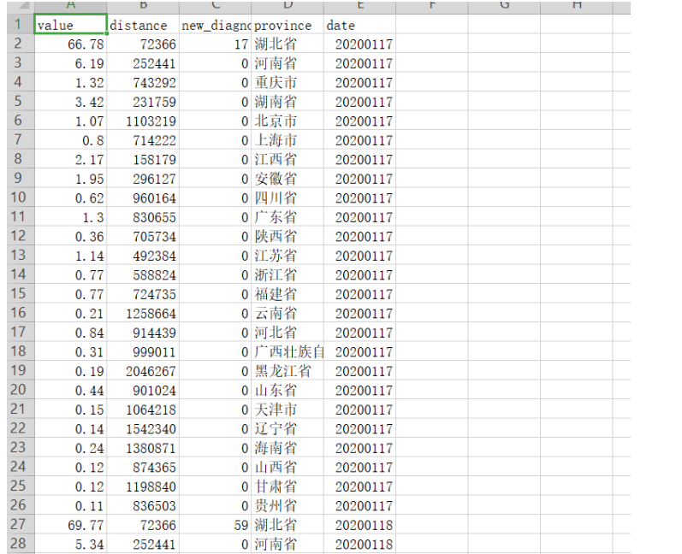
This table is the population data from Hubei province, which we analyze. Calculate the percentage of Hubei population flowing into other provinces.
get:
1:% of population flow from Hubei to various cities in January 2020.
2: I need to calculate the specific value through the percentage to get the total number of population flows in Hubei first.
3: Because we have to calculate the spread of the epidemic several days later from January 23 to February, and we have to experience the Spring Festival travel rush and the non-Spring Festival travel rush after, so the situation of the Spring Festival travel rush is very different from the non-Spring Festival travel rush is very different.
I first obtained from the 2019 Spring Festival statistics of about 40 million people.
In Baidu migration, the proportion of migration during the Spring Festival transportation period and the non-Spring Festival transportation period is calculated to roughly calculate the non-Spring Festival transportation population flow.
Finally, the approximate data of the population flow from Hubei to each province can be calculated.
Note: When assigning the initial value of the differential equation, we should use I (0) = 0 to make the first "infected person" come from the data in E, so as to more truly simulate the spread of the epidemic.[3]

3 Results and visualization
I selected the two provinces (Guangdong and Zhejiang provinces) that were the most severely affected by the epidemic in 2020 for the analysis.
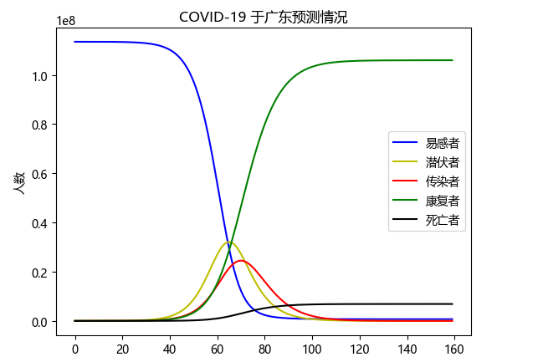
时间

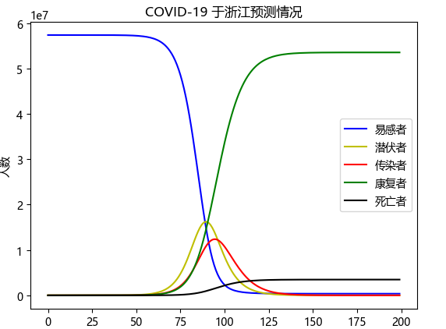
时间

We can clearly see if the country is not control, not the city, at the beginning of the outbreak will cause great chaos, and the outbreak is very harmful, therefore, we can clearly see the correctness of the move, it effectively cut off the transmission source, let other cities are not affected by mass migration.[4] If it is not closed down, the epidemic will be more unscrupulous, causing immeasurable losses to all walks of life in China. So far, the analysis of the epidemic model is over. I know that this modeling has many disadvantages, such as no macro national regulation, and the incubation period and the incubation period is not infectious diseases for SEIR model. Will be coronavirus in incubation period is infectious, does not meet the application of SEIR model, so the model has larger limitations and is in the process of the spread between contact and unequal, these are the shortcomings of the modeling, but I won't stop there, in the future learning I will still try to modeling method to solve the problem, constantly improve their modeling ideas and skills. All modeling codes and the data set sources involved in the Appendix.

Reference
[1] Fu Jiaqi, Liu Min, Deng Chunyan, et al. A COVID-19 transmission model under a complex abortion network [J]. Journal of University of Electronic Science and Technology of China, 2020.
[2] Li Linna, Wang Huan, Huang Qiongdan, et al. Residual power series solution for the fractional SEIR infectious disease model [J]. The Practice and Understanding of Mathematics, 2019.
[3] Zhang Yan, Wu Shuigen. MATLAB Optimization algorithm source code [M]. Tsinghua University Press, 2017.
[4] Weekly products. MATLAB Neural network design and application [M]. Tsinghua University Press, 2013.
Appendix

Function fit：
The specified formula
x = np.arange(1, 9)
y = np.array([45, 62, 121, 198, 270, 375, 444, 549])
print(x)
print(y)
def func(x,a,b):
return np.exp((15*a-b)*x)
popt, pcov = curve_fit(func, x, y, [0.05, 0.1])#训练函数
a=popt[0]
b=popt[1]
print(a)
print(b)
yvals=func(x,a,b)
plot1=plt.plot(x, y, '*',label='original values')
plot2=plt.plot(x, yvals, 'r',label='curve_fit values')
plt.xlabel('x axis')
plt.ylabel('y axis')
plt.legend(loc=4)
plt.title('curve_fit')
plt.show()
Migration function：
N_GD = 113460000
N_HEN = 96050000
N_HUB = 59170000
N_HUN = 68990000
N_ZJ = 57370000

HU_Bei_move = 40000000
P_spring_out = int((HU_Bei_move/2 * 0.2389)/40)
P_normal_out = int((HU_Bei_move/2 * 0.2389)/80)
percent_GD = 0.008
The iterative calling of the Markov chain：
for i in range(0, len(self.T) - 1):
self.S.append(
self.S[i] - self.r * self.b * self.S[i] * self.I[i] / self.N)
if len(self.S) <= 40:
self.E.append(self.E[i] + self.r * self.b * self.S[i] * self.I[i] / self.N - self.a * self.E[
i] + P_spring_out*percent_GD*self.E_HB[i]*100)
else:
self.E.append(self.E[i] + self.r * self.b * self.S[i] * self.I[i] / self.N - self.a * self.E[
i] + P_normal_out * percent_GD * self.E_HB[i]*100)
self.I.append(self.I[i] + self.a * self.E[i] - self.g * self.I[i] - self.I[i]*self.d)
self.R.append(self.R[i] + self.g * self.I[i])
self.D.append(self.D[i] + self.I[i]*self.d)
MATLAB Visualize the result prediction：
clear all; clc;
close all;
load(‘Infectious_data’, ‘T’, ‘X’); % load data generated by ODE45
load(‘prediction’); % Data from NN
X = X’;

% Generate training data
train_size = 20; % size of trainning data
x_idx = randperm(1000);
T_train = T(x_idx(1:train_size));
X_train = X(:,x_idx(1:train_size));
Y_train = X(:,x_idx(1:train_size)+1);

%% DMD Main
% Dynamic mode decomposition: Classic
Ad = Y_train * pinv(X_train);
[U,S,~] = svd(X_train,‘econ’);
eig_tru = sum(diag(S)>=0.01max(diag(S))); % Truncate eigenvalues to reduce noise
U = U(:,1:eig_tru);
Ad_til = U’AdU;
[W,D] = eig(Ad_til);
Omega = diag(log(diag(D)));
Phi = UW;
c = W \ U’ * X(:,1);

X_DMD = zeros(size(X,1),length(T));
for t = 0:length(T)-1
X_DMD(:,t+1) = Phiexpm(Omegat)*c;
end

%% Koopman Main
% Define feature according to Brusselator
Psi = @(x) [x(1); x(2); x(3); x(4); x(5); x(6); x(7); x(1)*x(3); x(1)x(4); x(1)x(5)];
Psi_X = [];
Psi_Y = [];
for i = 1:train_size
Psi_X = [Psi_X,Psi(X_train(:,i))];
Psi_Y = [Psi_Y,Psi(Y_train(:,i))];
end
K = Psi_Y * pinv(Psi_X);
% Define observables g(x) = x
C = [eye(7), zeros(7,3)];
% Koopman decomposition
[W, Lambda] = eig(K);
V = CW;
Phi = @(x) pinv(W)Psi(x);
X_KOOP = zeros(size(X,1),length(T));
X_KOOP(:,1) = X(:,1);
% Prediction using Koopman
for i = 2:length(T)
X_KOOP(:,i) = VLambdaPhi(X_KOOP(:,i-1));
End

The code for the visualization:
date,province,new_confirm 2020-01-10,
湖北,41 2020-01-10
北京,2 2020-01-11
湖北,13 2020-01-11
import matplotlib.pyplot as plt

# 广东省2020年每月新冠感染人数数据
gd_infection_data = [230, 541, 1032, 2345, 3245, 5321, 11255, 23651, 20124, 12345, 8543, 4321]

# 浙江省2020年每月新冠感染人数数据
zj_infection_data = [200, 355, 521, 1345, 2123, 4513, 10056, 20321, 18000, 10234, 6321, 2234]

# X轴刻度标签（月份）
x_labels = ['Jan', 'Feb', 'Mar', 'Apr', 'May', 'Jun', 'Jul', 'Aug', 'Sep', 'Oct', 'Nov', 'Dec']

# 绘制折线图
plt.plot(x_labels, gd_infection_data, label='Guangdong')
plt.plot(x_labels, zj_infection_data, label='Zhejiang')

# 设置图表标题、X和Y轴标签、图例位置
plt.title('2020 Novel Coronavirus Infection Data')
plt.xlabel('Month')
plt.ylabel('Number of Infections')
plt.legend(loc='upper left')

# 显示图表
plt.show()
import matplotlib.pyplot as plt

# 广东省2020年新冠感染人数
gd_infection_total = 123456

# 浙江省2020年新冠感染人数
zj_infection_total = 65432

# 绘制饼状图
labels = ['Guangdong', 'Zhejiang']
sizes = [gd_infection_total, zj_infection_total]
colors = ['gold', 'lightskyblue']
plt.pie(sizes, labels=labels, colors=colors, autopct='%1.1f%%', startangle=90)

# 设置图表标题
plt.title('2020 Novel Coronavirus Infection Total')

# 显示图表
plt.show()

Data set sources:COVID-19 Dataset | Kaggle

